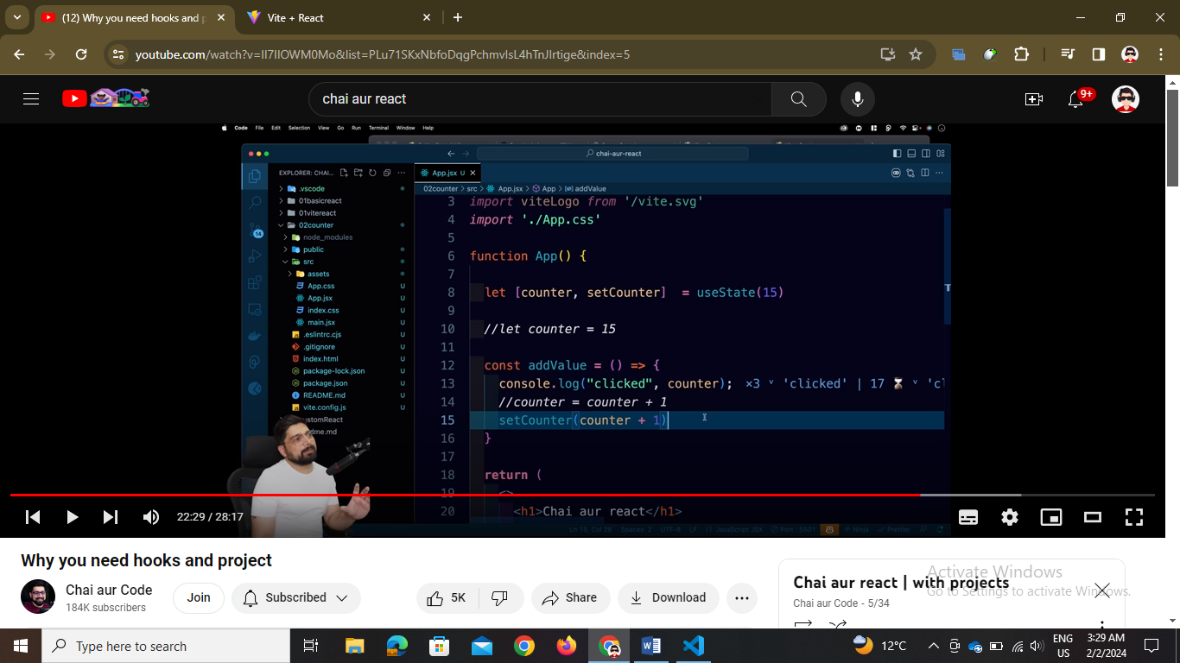

We use hooks in react as ui mai jitney components hai with counter as variable hook directly un sab ko change kardega

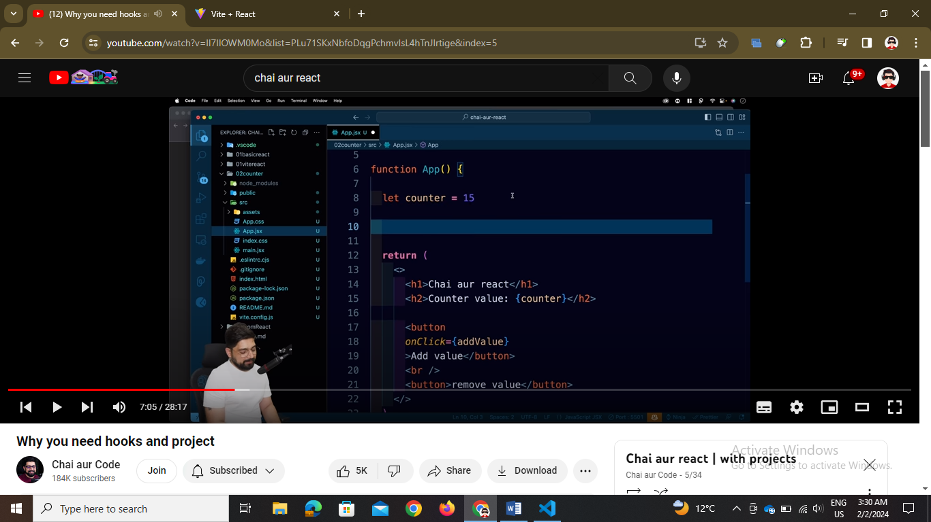

We used onclick function and passed a function addValue or removeValue

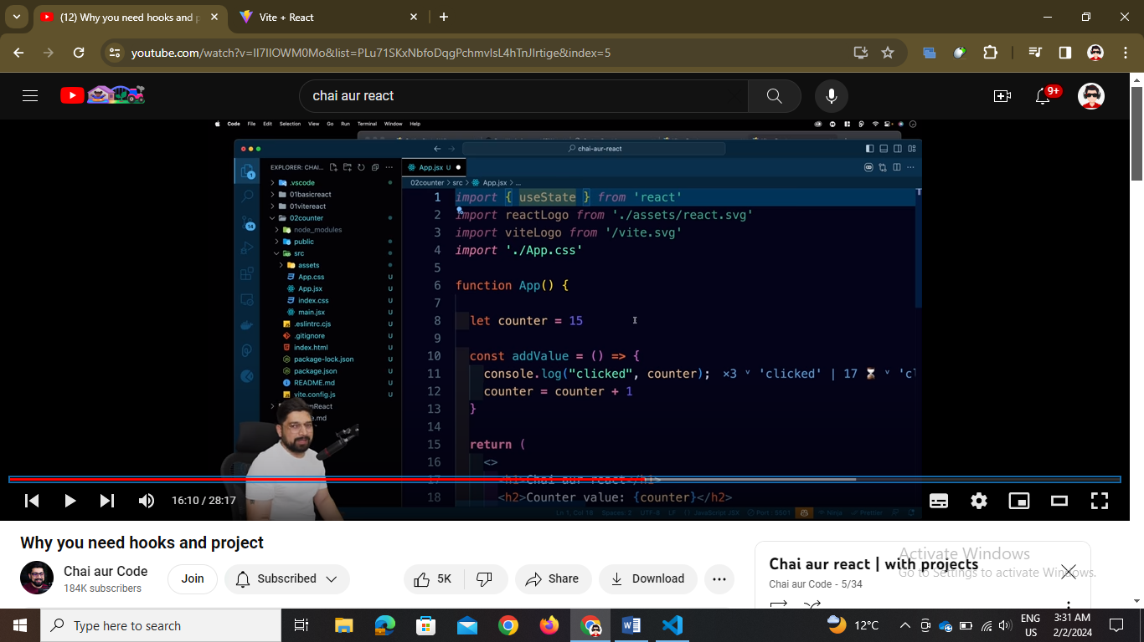

Import useState hook it is use to create a counter variable and then setCounter a function for setting the counter value to +1 or -1

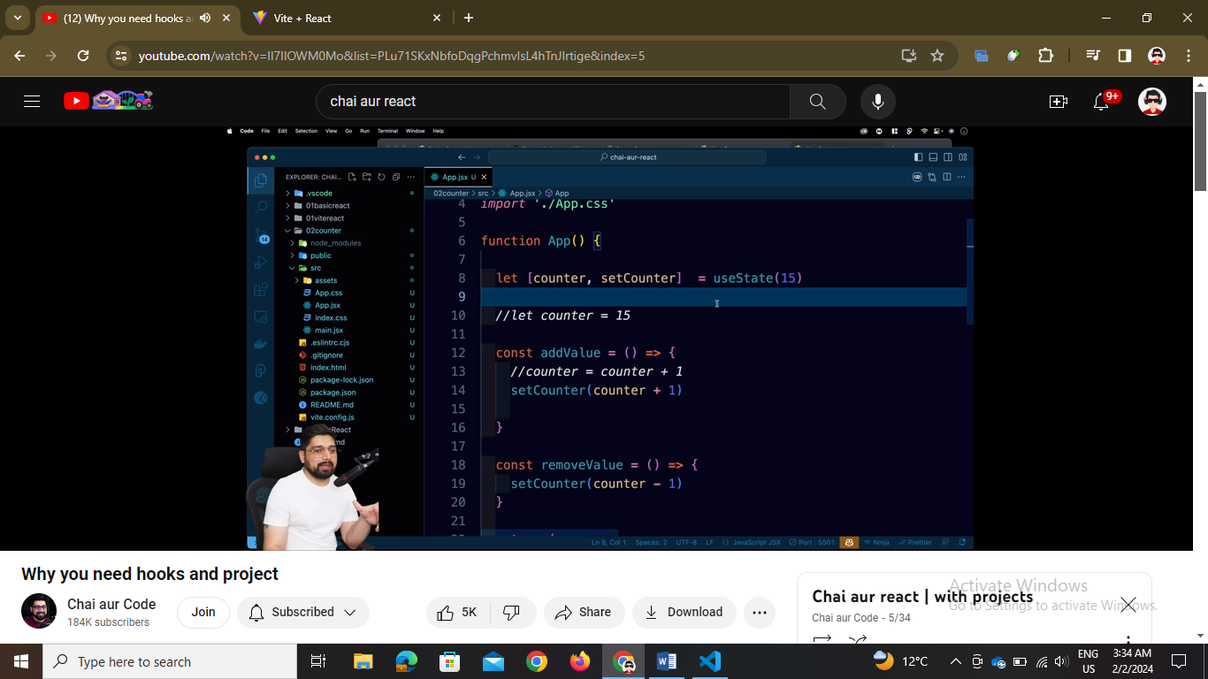

import { useState } from "react";

// decoded by babel js

import "./App.css";

function App() {

  // const counter = 5;

  const [counter, setCounter] = useState(15);

  const addValue = () => {

    if (counter >= 20) return;

    setCounter(counter + 1);

  };

  const removeValue = () => {

    if (counter <= 0) return;

    setCounter(counter - 1);

  };

  return (

    <>

      <h1>React Chai !!</h1>

      <h2>Counter Value: {counter}</h2>

      <button onClick={addValue}>Increment</button>

      <button onClick={removeValue}>Decrement</button>

    </>

  );

}

export default App;